**PROJECT REPORT**

**ON**

**“**Hybrid Solar Inverter**”**

*Submitted in complete fulfillment of the requirements for the degree of*

**Diploma**

**In**

**Electrical Engineering**

Under The Guidance Of

**Project Supervisor PROJECT COORDINATOR**

Dr.Raj Kumar Garg  **DILJINDER SINGH**

Assistant Prof.,EIE Associate Prof. , EIE

**SUNIL KUMAR**  Assistant Prof.,EIE

**Submitted By:**

Himanshu Raj Regd No-1610241

Anuj Kumar Regd No-1610222

Dipanshu Raj Regd No-1610248

Akash kumar Regd No-1610318

Amit kumar Regd No-1610073



**Sant Longowal Institute of Engineering And Technology**

**Longowal-148106, Distt. Sangrur (Punjab**

**C E R T I F I C A T E**

This is to certify that

**HImanshu Raj**  (DEE-CEN/1610242),

**Anuj Kumar**

(DEE-CEN/1610222),

**Dipanshu Raj** (DEE-CEN/1610248),

**Akash Kumar**

(DEE-CEN/1610318),

**Amit Kumar**

(DEE-CEN/1610073),

have successfully completed their project on

**“Hybrid Solar Inverter ’’**

for the complete fulfillment of the award

Of ICD in Electrical Engineering

As prescribed by

Sant Longowal Institute of Engineering And Technology,

Longowal(148106)

**Raj.Kumar Garg Dr. Sanjay Marwaha**

***SUPERVISOR’S SIGNATURE HOD’S SIGNATURE***

**Department Of Electrical And instrumentation Engineering**

**ACKNLODEMENT**

We have taken efforts in this project. However, it would not have been possible without the kind support and help of many individuals and organizations. we would like to extend my sincere thanks to all of them.

We are highly indebted to Project supervisor Dr.Raj Kumar Garg(EIE),

PProject Codinator DILJINDER SINGH( EIE) SUNIL KUMAR (EIE).

for their guidance and constant supervision as well as for providing necessary information regarding the project & also for their support in completing the project.

we would like to express my gratitude towards my parents & member of sant longowal institute of engineering and technology for their kind co-operation and encouragement which help me in completion of this project.

Our thanks and appreciations also go to my colleague in developing the project and people who have willingly helped me out with their abilities.

**ABSTRACT**

Electricity is the form of energy and we need it just for about everything. The world demand for electric energy is constantly increasing and conventional energy resources are diminishing , moreover their prices are rising for all there reason the need. for alternative energy sources has become necessary and solar energy in particular has proved to be very promising alternative because of its only availability and pollution free nature. Our project is about to developing a **Hybrid Solar Inverter** that generate power in same way as a common grid tie solar system. A grid tie solar system i.e simply connected to electrical grid and therefore use electricity both from solar panel system and grid if needed. The main disadvantage of the system is when the grid is off the power supply will be shut down. This disadvantage is overcome by the Hybrid solar inverter that use of battery to store energy for later use operate at back up power supply during blackout or shut down.By this system we reduce electricity bill, become Independent for energy needs and stayed powered during power cuts and save our environment also by moving a step toward using renewable sources of energy.

Contents

1. introduction
2. Problem statement
3. Introduction to solar energy
4. Generation of electricity of Solar Energy
5. Basic principle of Solar inverter
6. Need of solar inverter
7. Type of solar inverter
8. Objective and scope
9. Basic layout diagram of solar inverter
10. Design approach of solar inverter
11. Modelling approach of solar inverter
12. Material Required
13. Estimation and Coasting of the project
14. Advantage & Application
15. Conclusion
16. Introduction

**I**n today’s climate of growing energy needs and increasing environmental concern, alternatives to the use of non-renewable and polluting fossils fuels have to be investigated. One such alternative is solar energy. Solar energy is quite simply the energy produced directly by the sun and collected elsewhere., normally the earth.The main aim of this project is to use solar energy to household load using an inverter. Solar energy is converted to electrical energy by photo-voltaic(PV) cells. This energy stored in batteries during day time for he utilization purpose whenever required. A solar inverter,or PV inverter , converts direct current(DC) output of a photovoltaic solar panel into a utility frequency alternating current(AC) that can be fed into a commercial electrical grid or used by a local, off line electrical network. By this system we reduce electricity bill, become Independent for energy needs and stayed powered during power cuts and save our environment also by moving a step toward using renewable sources of energy.

2. Problem Statement

The world demand for electric energy is constantly increasing and conventional energy resources are diminishing and are even threatened to be depleted moreover. Their prices are rising for these reasons ,the need for the alternative energy sources has becomes indispensable and solar energy in particular has proved to be a very a promising alternative because of it’s availability and pollution - free nature. Due to the increasing efficiency and decreasing cost of photo -voltaic cells and the improvement of switching technology use for power conversion. our goal is to be design an inverter powered by the PV panels and that could supply stand alone supply ac loads solar panel produce directly current(DC) and to connect this panel to electricity grid use them and industrial applications. we should have an ac output at a certain required voltage level frequency.The conversion from DC to AC is essentially accomplished by means of a DC- AC inverter. Which is major component in the system.

3. Introduction To Solar Energy

Today’s climate of growing energy needs and increasing environmental concern, alternative to the use of non renewable and polluting fossil fuels have to be investigated. One such alternative is solar energy. Solar energy is quite simply the energy produced directly by the sun and collected elsewhere, normally the earth. The sun creates its energy through a thermonuclear process that converts about 650,000,0001 tons of hydrogen to helium every second. The process creates heat and electromagnetic radiation. The heat remains in the sun and is instrumental in maintaining the thermonuclear reaction. The electromagnetic radiation (including visible light, infrared light,and ultraviolet radiation) streams out into space in all directions. Only a very small fraction of the total radiation produces reaches the earth. The radiation that reach the earth is the direct source of nearly every type of energy used today. Much of the world’s required energy can be supplied directly by solar power. More steel can be provided indirectly. The practically of doing so will be examined,as well as the benefits and drawbacks. In addition, the uses solar energy currently applied to will be noted. Due to the nature of solar energy, two components are required to have a functional solar energy generator. These two components are a collector and a storage unit. The collector simply collects the radiation that falls on it and converts a fraction of it to other form of energy (either electricity and heat or heat alone). The storage unit is required because of the non constant nature of solar energy; at certain times only a very small amount of radiation will be received. At night or during heavy cloud cover, for example, the amount of energy produced by the collector will be quite small. The storage unit can hold the excess energy produced during the periods of maximum productivity, and release it when the productivity drops. In practice, a backup power supply is usually added, two, for the situations when the amount of energy required is greater than both what is being produced and what is stored in container.

4.Generation Of Electricity From Solar Energy

Photovoltaic cells,by their very nature, convert radiation to electricity. This phenomenon has been known for well over half a century, but until recently the amounts of electricity generated were good for little more than measuring radiation intensity. Most of the photovoltaic cells on the market today operate at an efficiency of less than 15%; that is, of all the radiation that falls upon them, less than 14% of it is converted to electricity. The maximum theoretical efficiency for a photovoltaic cell is only 32.3% , but at this efficiency, solar electricity is very economical. Most of our other forms of electricity generation are at a lower efficiency than this. Unfortunately, reality still lags behind theory and a 15% efficiency is not usually considered economical by most power companies, even if it is fine for toys and pocket calculators. Hope for bulk solar electricity should not be abandoned, however for recent scientific advances have created a solar cell with an efficiency of 28.2% efficiency in the laboratory. This type of cell has yet to be filled tested, if it maintains its efficiency in the uncontrolled environment of the outside world, and if it does not have a tendency to break down, it will be economical for power companies to build solar power facilities after all. Now , we know that solar panel transfers electrons into DC, and most appliances at home is using AC, that’s why we use inverters.

5.Basic Principle Of Solar Inverter

A solar inverter , or PV inverter, converts the variable direct current(DC) output of a photovoltaic (PV) solar panel into a utility frequency alternating current(AC) that can be fed into a commercial electrical grid or used by the local, off grid electrical network.It is a critical component in a photovoltaic system, allowing the use of with photovoltaic arrays, including maximum power point tracking and anti-islanding protection.

6.Need Of Solar Inverter

There are two types of sources for electrical power generation. One is conventional and other is non-conventional. Today to generate most of electrical power conventional sources like coal, gas, nuclear power generators are used. Some of conventional source are polluted the environment to generate the electricity. And nuclear energy is not much preferable because of it’s harmful radiation effect on the mankind. After some of 10 years conventional sources will not sufficient enough to fulfil the requirements of mankind. So some of the electrical power should be generated by non-conventional energy sources like solar, wind. With the continuously reducing the cost of PV power generation and the further intensification of energy crisis, PV power generation technology obtains more and more applications. However, AC power is not always available and the need for mobility and simplicity has given batteries an advantage importable power. Thus for portable AC power inverters are needed. Inverter takes from a battery or a solar panel as input and convert into an AC voltage output.

7.TYPES OF SOLAR INVERTER

May be classified into three broad type .

1. Stand alone inverter.
2. Grid tie inverter.
3. Battery back up inverter.
4. Stand Alone Inverter

Stand alone inverters used in isolated system where the inverter draw its DC energy from battery charged by photovoltaic arrays. Many stand alone inverter also incorporate integral battery chargers to replenish the battery from an AC source when available. Normally these do not interface in anyway with the utility grid and as such are not required to have anti -islanding protection.

B.Grid tie Inverter

Grid tie inverter which match phase with a utility supplied sine wave. Grid tie inverter are designed to shut down automatically upon loss of utility supply, for safety reason .They donot provide backup power during utility outages.

C.Battery Backup Inverter

Battery backup inverters are special inverter which are designed to draw energy from a battery manage the battery charge via an onward charger and export excess energy to the utility grid. These inverter are capable of supplying AC energy to select loads during a utility outage and are required to have anti-islanding protection.

8.OBJECTIVE AND SCOPE

The main objective of this project is to design and construct a PV based system that produce electric energy and operates in dual mode, Supplying stand alone AC loads and use grid power when solar power absent .if both are absent then use of battery stored energy operate at back up power supply during blackout or shut down. Our goal is to design and develop an inverter that will handle the task described.

1. **BASIC LAYOUT DIAGRAM OF SOLAR HYBRID SYSTEM**

(DC Coupled battery)

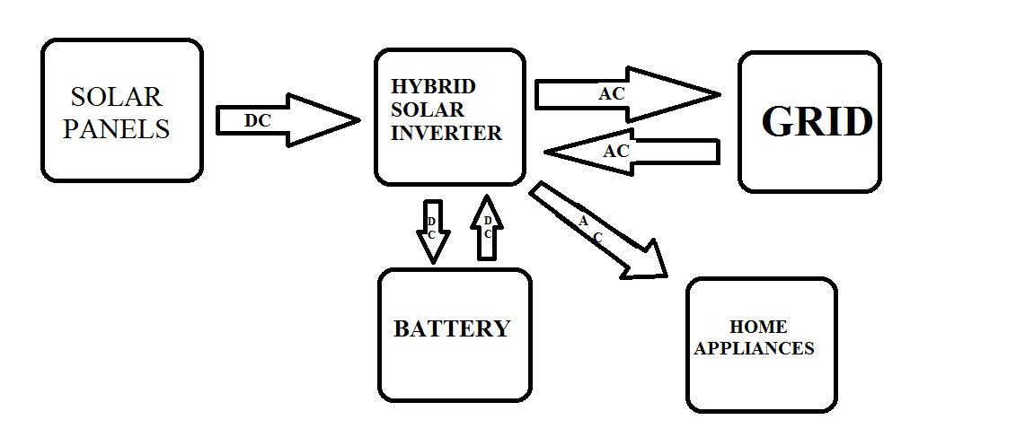

1. **DESIGN APPROACHES OF SOLAR INVERTER**

There are many topologies or circuit design for creating higher poer AC from low voltage dc. Two common topologies are the Push-Pull and H-bridge. The Push -Pull topology is suitable for producing square wave inverter and modified square wave inverter while the H-Bridge is useful for producing square and sine wave inverter.

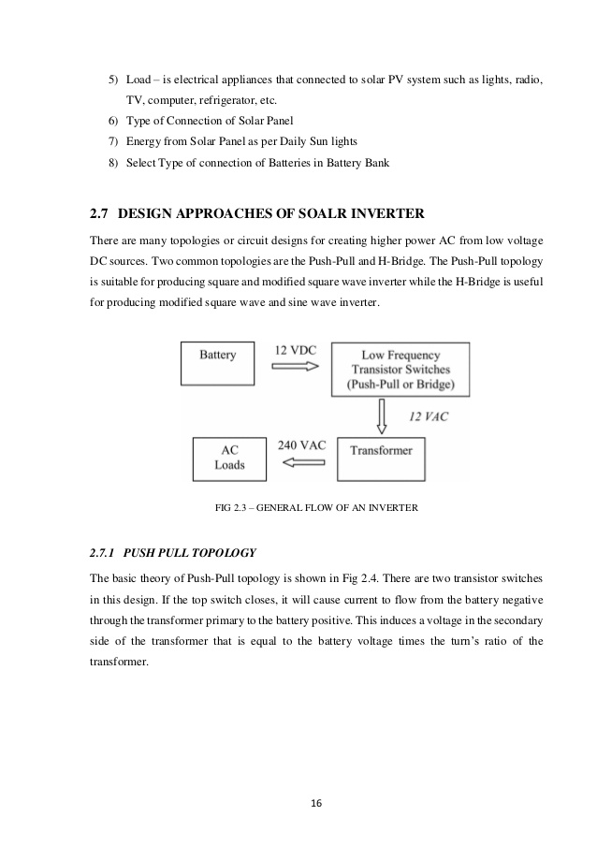

**10.1 .** PUSH-PULL TOPOLOGY FOR SQUARE WAVE OUTPUT

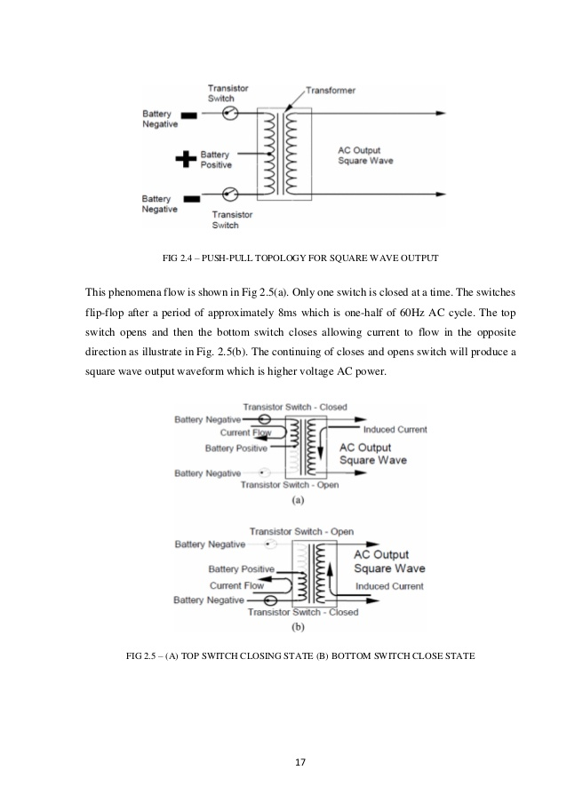This Phenomena Flow is shown in figure [ ]only one switch is closed at a time .The switches filp-flop after a period of approximately 8ms which is one half of 60Hz AC cycle .The top switch opens and then the bottom switches closes allowing current to flow in the other direction as illustrated in figure[ ] .The continue closes and open switch will produce a square wave output waveform which is higher ac voltage power.



10.2 . Internal block diagram of hybrid inverter unit.

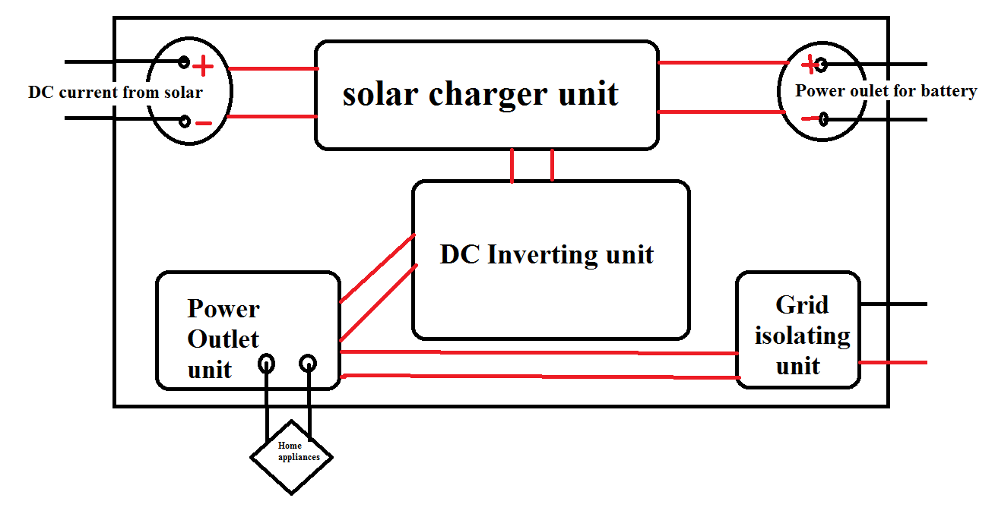

10.3. SOLAR INVERTER PARTS There are few sections of the solar inverter they are:

1.The solar battery recharger,

2.The solar panel

3 .Rechargeable battery

4 .The inverter.

1. **MODELLING APPROACH OF 200 W SOLAR INVERTER**

A successful design involves accurate knowledge of daily electrical load calculation and accounts for all worst case scenarios which might possibly occur during operation. A good designer will be pragmatic and keep the costs down by cutting on unnecessary over sizing the system.

* 1. SELECTION BATTERY SIZE AND SOLAR PANEL

Now let’s begin, suppose we have to design an inverter for maximum load of 200 W and required backup time for batteries is 1 hour and we have to model a solar inverter than inverter ratings, required no. of solar panels and no of batteries are calculated as follows. Inverter should be greater 25% than the total load 200*(25/100)=50.

200+50=250 W. This is the rating of the UPS(inverter).

Now the required backup time in hours = 1 hours, suppose we are going to install (12 volt 7AH) 2 batteries

In parallel

Then 252 W will be obtained

For direct conversion of DC power into the required ac power

*Solar pannels of 12 V 50 W Panels in Amount 3 connected in series.*

FOR DEMONSTRATION PURPOSE WE USE ONLY ONE SOLAR AND ONE BATTERY OF ABOVE SAID RAITING CONNECTED WITH THE INVERTER ONLY.

But the inverter is capable to transfer 250 w load

* 1. Design of inverter

11.2a.Selection Of Topology

The push-pull topology was the first step in electronic inverter technology. The advantage of this topology is the simplicity of the overall circuit designed and cost effective in manufacturing. But , the major problem is the current in the transformer has to suddenly reverse directions. This will causes a large reduction in efficiency.The disadvantages of this topology are complexity of the transformer design and higher transformer losses in square wave design. The square wave inverter is the simplest and cheapest form of inverter. But , the output waveform of square wave inverter has high total harmonic distortion (THD). For small load applications in PV system , the inverter can be designed by using the push-push topologies. This topology is simple and easy to design . This kind of inverter can run the lamp and fan. However, some modification of the design is needed for this topology. The next step will continue with further improvement in the circuit design and simulation of the topology in order to improve and modify the circuit design.

In this we are using electronic inverter IC named CD4047.

IC CD4047 The CD4047B is capable of operating in either the monostable or astable mode. It requires an external capacitor (between pins 1 and 3) and an external resistor (between pins 2 &3) . To determine the output pulse width in monostable mode , and the output frequency in the astable mode. Astable operation is enabled by a high level on the astable input or low level on the astable input. The output frequency (at 50% duty cycle) at Q and Q output is determined by the timing components. A frequency twice that of Q is available at the oscillator output; 50% duty cycle is not guranteed. Monostable operation is obtained when the device is triggered by low to high transistion at +trigger input or HIGH to LOW transition at -triggered input. The device can be triggered by applying simultaneous low to high transition to both the +trigger and retriggered inputs. A high level on reset input resets the output Q to low, Q to high . MOSFET (Metal Oxide Semiconductor Field Effect Transistor) is a special type of field effect transistor (FET) that works by electronically varying the width of the channel along which charge carriers (electrons or holes) flow . The wider the channel , the better the device conducts. The charge carriers inter the channel at the source, and exit via the drain.

Calculation

The oscillated output frequency on Pin 10 and 11 can be determined using the following formula.

**f = 1 / 8.8 x R*C**

In our case , we want 50 hz frequency. As we know that the duty cycle is 50%, so frequency should be 100 hz . Then again **f =1/8.8xR*C**

f=1/8.88*1M*0.01

f will be approx 113hz approx,and duty cycle is 50% ,So we can get approx 50 Hz

**[R is connecton the pin no 1 ,C is connected on 2 ,Pin no 3 is common]**

11.2b. Circuit Diagram

11.3a. Design of solar charger

The efficiency of a solar charging system depends on the weather conditions. Solar panels generate the most electricity on clear days with abundant sunshine. Commonly, the solar panel gets four to five hours of bright sunlight in a day. If the weather is cloudy, it affects the battery charging process . for charging battery constant voltage should be given is should be to much and must not be less than required so a voltage regulator is used to maintain constant voltage across the battery terminal and also for the inverter input .in our case we are going to use voltage regulator [ IC LM317 ] .

11.3b. Circuit diagram

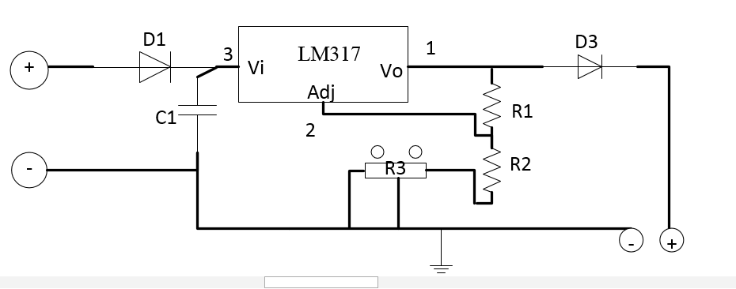

11.4Design of selector switch

The concept of the selector switch is to select the source of power I.e either solar to ac or ac supply from the grid. Foe developing this we are going to use two SPDT relay. Preferred source is connect to the no terminal of the relay and alternative source of the power is connect to the NC terminal of the relay . for the operation of the relay rectifier bridge with the transformer . if the preferred source is available then power supply is given by the preferred source if not, given by the alternative source.

11.4b.Circuit Diagram

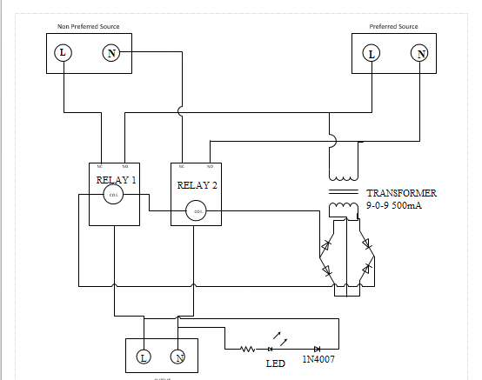

|  |  |  |  |  |
| --- | --- | --- | --- | --- |
|  | **Component** | **Rating** | | **Quantity** |
| **A.The Solar Battery Charger** | | | | |
| 01. | IC LM317(Voltage Regulator) | 1.25V to 37V | | 01 |
| 02. | Diode | IN4007 | | 01 |
| 03. | Ceramic Capacitor | 103(0.01 µ) | | 01 |
| 04. | Potentiometer | 10KΩ | | 01 |
| 05. | Resistor | 470Ω, 220Ω | | 01+03 |
| 06. | Schottky Diode | 3A, 50V | | 01 |
| 07. | LED | 3mm | | 01 |
| **B.Inverter** | | | | |
| 01. | IC CD4047. | CMOS Low Power. Monostable/Astable Multivibrator | | 02 |
| 02. | Potentiometer | 105(1M) | | 01 |
| 03. | Polyester Capacitor | 100V,(0.01µF) 103j | | 01 |
| 04. | Resistor | 330Ω,1/2W | | 03 |
| 05. | Diode | IN5408 | | 02 |
| 06. | MOSFET | P55NF060 | | 02 |
| 07. | Diode | IN4007 | | 01 |
| 08. | Transformer | 12/220 (12-012) | | 01 |
| **C.Selector Switch** | | | | |
| 01. | SPDT Relay | 12V DC | 7A 120VAC | 02 |
| 10A 24VDC |
| 02. | Transformer | 220/9 V (9-0-9) | | 01 |
| 03. | Diode | IN4007 | | 05 |
| 04. | Capicator | 25V,1000µF | | 01 |
| 05. | LED | 3mm | | 01 |
| 06. | Resistor | 47KΩ | | 01 |
| **D.Miscellaneous** | | | | |
|  | Battery |  | |  |
|  | PCB |  | |  |

12.2.Component Description:-

**01.IC LM317(Voltage Regulator IC) :-**

**LM317 is a 3-terminal regulator **IC**** and it is very simple to use. it can also be used as a fixed voltage regulator, current limiter, Battery charger, AC voltage regulator and even as an adjustable current regulator. One notable drawback of this IC is that it has a voltage drop of about 2.5 across it during regulation.

### Pin Configuration:

|  |  |  |
| --- | --- | --- |
| ****Pin Number**** | ****Pin Name**** | ****Description**** |
| 1 | Adjust | This pins adjusts the output voltage |
| 2 | Output Voltage (Vout) | The regulated output voltage set by the adjust pin can be obtained from this pin |
| 3 | Input Voltage (Vin) | The input voltage which has to be regulated is given to this pin |

**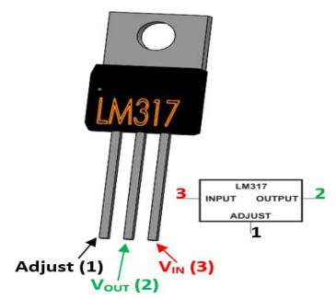 Features:**

* Adjustable 3-terminal positive voltage regulator
* Output voltage can be set to range from 1.25V to 37V
* Output current is 1.5A
* Maximum Input to output voltage difference is 40V, recommended 15V
* Maximum output current when voltage difference is 15V is 2.2A
* Operating junction temperature is 125°C
* Available in To-220, SOT223, TO263 Package

**02. IC CD4047 :-**

**CD4047 Low Power Monostable/Astable Multivibrator**

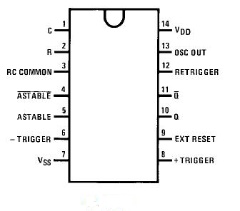

**General Description:-**

The CD4047 is capable of operating in either the monostable or astable mode. It requires an external capacitor (between pins 1 and 3) and an external resistor (between pins 2 and 3) to determine the output pulse width in the monostable mode, and the output frequency in the astable mode. Astable operation is enabled by a high level on the astable input or low level on the astable input. The output frequency (at 50% duty cycle) at Q and Q outputs is determined by the timing components. A frequency twice that of Q is available at the Oscillator Output; a 50% duty cycle is not guaranteed. Monostable operation is obtained when the device is triggered by LOW-to-HIGH transition at + trigger input or HIGH-to-LOW transition at − trigger input. The device can be retriggered by applying a 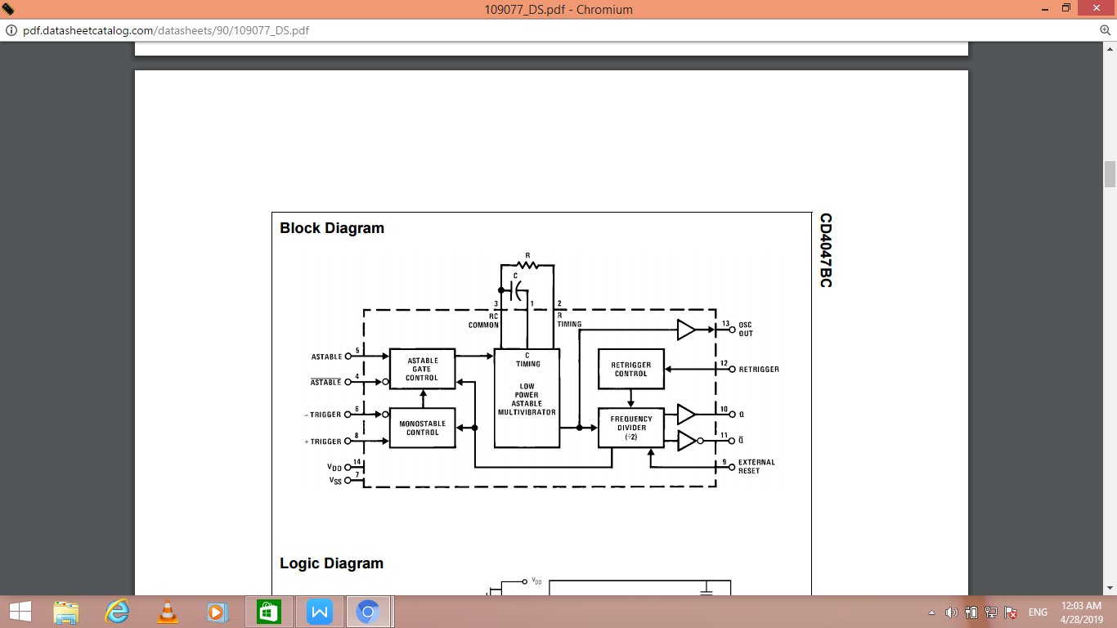simultaneous LOW-to-HIGH transition to both the + trigger and retrigger inputs. A high level on Reset input resets the outputs Q to LOW, Q to HIGH.

**Features:-**

■ Wide supply voltage range: 3.0V to 15V

■ High noise immunity: 0.45 VDD (typ.)

■ Low power TTL compatibility: Fan out of 2 driving 74L or 1 driving 74LS.

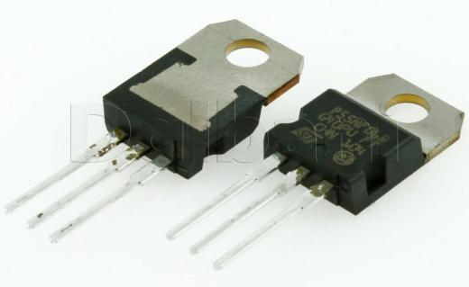**03.MOSFET(P55NF060) :-**

N CHANNEL POWER MOSFET TRANSISTOR 50 AMPERE 60 VOLT

DESCRIPTION:-

50N06 is three-terminal silicon device with current conduction capability of about 50A, fast switching speed. Low on-state resistance, breakdown voltage rating of 60V, and max threshold voltages of 4 volt. It is mainly suitable electronic ballast, and low power switching mode power appliances.

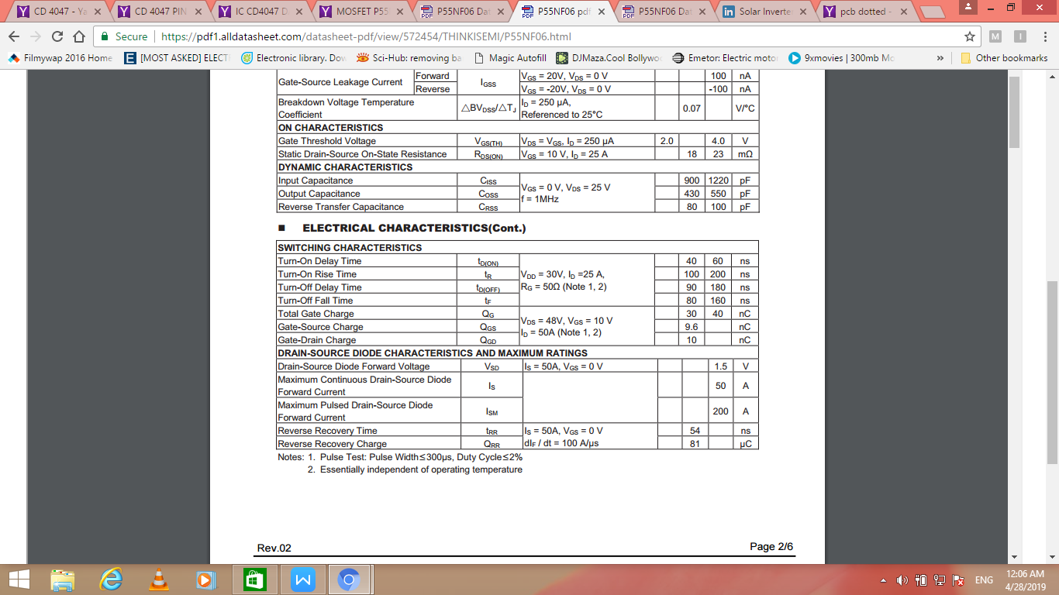

FEATURES:-

* RDS(ON) = 23m@VGS = 10 V
* Ultra low gate charge ( typical 30 nC )
* Low reverse transfer capacitance ( CRSS = typical 80 pF )
* Fast switching capability
* 100% avalanche energy specified

## Improved dv/dt capability

**04. SPDT RELAY :-**

[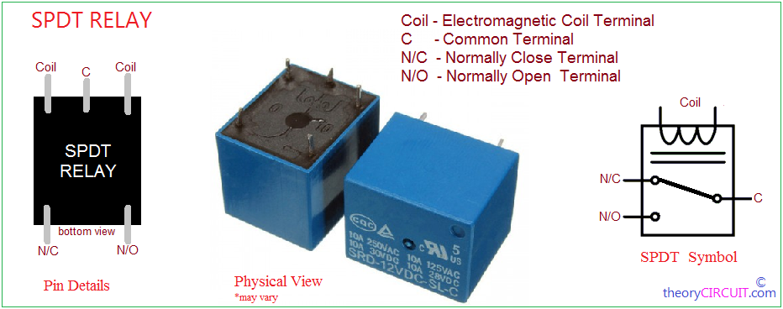](http://www.theorycircuit.com/wp-content/uploads/2017/08/spdt-relay.png)Relay is a electro-mechanical switch used to control high power application through low power signal electronic circuits Single Pole .Typical Relay contains Electromagnetic coil, N/O contact, N/C contact and Common contact, electromagnetic coil accepts low voltage DC bias and becomes electromagnet to attract the common terminal lever and interchanges the connection between N/C, N/O contacts.

Double Throw (SPDT) Relay contains two coil terminals and common terminal, then two switching terminals N/O (Normally Open), N/C (Normally Close) .If there is not enough DC supply in coil terminals then Relay represents idle condition that is common terminal connected in N/C terminal. When the coil gets required DC supply then coil gets Magnetically Energized and this magnetic flux force attracts common terminal lever which is made of iron and makes the connection to N/O terminal, now the N/C becomes open.

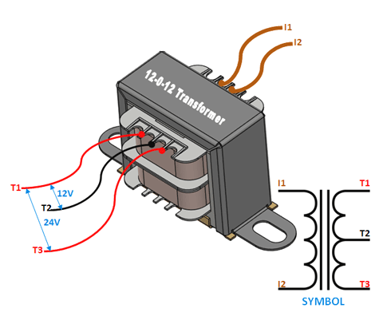**05.TRANSFORMER**

A **transformer** is a static electrical device that transfers electrical energy between two or more [circuits](https://en.wikipedia.org/wiki/Electrical_network" \o "Electrical network). A varying current in one coil of the transformer produces a varying [magnetic flux](https://en.wikipedia.org/wiki/Magnetic_flux" \o "Magnetic flux), which, in turn, induces a varying [electromotive force](https://en.wikipedia.org/wiki/Electromotive_force" \o "Electromotive force) across a second coil wound around the same core. Electrical energy can be transferred between the two coils, without a metallic connection between the two circuits. [Faraday's law of induction](https://en.wikipedia.org/wiki/Faraday's_law_of_induction" \o "Faraday's law of induction) discovered in 1831 described the induced voltage effect in any coil due to changing magnetic flux encircled by the coil.

Transformers are used for increasing or decreasing the alternating voltages in electric power applications, and for coupling the stages of signal processing circuits.

**06. DIODE (IN4007)**

****Description:****

****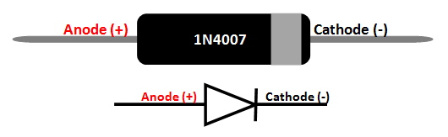****A diode is a device which allows current flow through only one direction. That is the current should always flow from the Anode to cathode. The cathode terminal can be identified by using a grey bar as shown in the picture above.

****1N4007 Diode****,

the maximum current carrying capacity is 1A it withstand peaks up to 30A. Hence we can use this in circuits that are designed for less than 1A.  The reverse current is 5uA which is negligible. The power dissipation of this diode is 3W.

**IN5408 Diode** is 3.0A RECTIFIER diode

Features

* High Current Capability and Low Forward Voltage Drop •
* Surge Overload Rating to 200A Peak •
* Low Reverse Leakage Current •
* Lead Free Finish, RoHS Compliant (Note 3)

**07.Capacitor**

A Polyester capacitor offer a very low tolerance value, which equivalent to 5% or 10%. These capacitors use s layers of metal and Mylar dielectric or polyester in order to make a wide range of capacitance

12.3 Indicator leds

We are using leds to indicate the power output id given by invert or local grid. In out project green led on the selector switch indicate the power is available out . In indicator circuit the led indicate the presence of the grid power supply and if not it will not glow. Power led on the selector switch board still glow then power is provided by the inverter..green light on the indicator circuit show the presence of the solar output .

|  |
| --- |
| 1 |

|  |  |  |  |  |  |  |  |  |  |  |  |  |  |
| --- | --- | --- | --- | --- | --- | --- | --- | --- | --- | --- | --- | --- | --- |
| |  |  |  |  |  |  |  | | --- | --- | --- | --- | --- | --- | --- | |  |  |  |  |  |  |  | | **Component** | **Rating** | | **Quantity** | **Cost per unit(rs)** | **Cost total** |
| **A.The Solar Battery Charger** | | | | |  |  |
| 01. | IC LM317(Voltage Regulator) | 1.25V to 37V | | 01 | 15 | 15 |
| 02. | Diode | IN4007 | | 01 | 0.25 | 0.25 |
| 03. | Ceramic Capacitor | 103(0.01 µ) | | 01 | 2 | 2 |
| 04. | Potentiometer | 10KΩ | | 01 | 6 | 6 |
| 05. | Resistor | 470Ω, 220Ω | | 01+03 | 0.25 | 1 |
| 06. | Schottky Diode | 3A, 50V | | 01 | 5 | 5 |
| 07. | LED | 3mm | | 01 | 1 | 1 |
| **B.Inverter** | | | | |  |  |
| 01. | IC CD4047. | CMOS Low Power. Monostable/Astable Multivibrator | | 01 | 18 | 18 |
| 02. | Potentiometer | 105(1M) | | 01 | 8 | 8 |
| 03. | Polyester Capacitor | 100V,(0.01µF) 103j | | 01 | 5 | 5 |
| 04. | Resistor | 330Ω,1/2W | | 03 | 0.25 | 0.75 |
| 05. | Diode | IN5408 | | 02 | 0.25 | .5 |
| 06. | MOSFET | P55NF060 | | 02 | 30 | 60 |
| 07. | Diode | IN4007 | | 01 | 0.25 | 0.25 |
| 08. | Transformer | 12/220 (12-012) | | 01 | 325 | 325 |
| **C.Selector Switch** | | | | |  |  |
| 01. | SPDT Relay | 12V DC | 7A 120VAC | 02 | 25 | 50 |
| 10A 24VDC |  |  |
| 02. | Transformer | 220/9 V (9-0-9) | | 01 | 50 | 50 |
| 03. | Diode | IN4007 | | 05 | 0.25 | 2.25 |
| 04. | Capacitor | 25V,1000µF | | 01 | 5 | 5 |
| 05. | LED | 3mm | | 01 | 2 | 2 |
| 06. | Resistor | 47KΩ | | 01 | 0.25 | .25 |
| **D.Miscellaneous** | | | | |  |  |
|  | Battery |  | | 1 | 250 | 250 |
|  | PCB |  | | 2 | 40 | 80 |
|  | Solar panel | 12v 50 w | | 01 | 1100 | 1100 |
| 2 pin terminals {8} | | | | | 5 | 40 |
| Solder wire ,flux and pcb wires etc. | | | | | 20 | 20 |
| Ply Wood and Fitting cost | | | | | 250 | 250 |
| TOTAL | | | | |  | 2297.25 |

GRAND TOTAL = Total price+ [ Transportation cost + Defective product ]- 15% of total cost

= 2047.25+344.5

**=2661.75 Rs APPROX= 2600Rs**

1. Applications

* DC DC Power source utilization.
* power supply.

1. Advantages
2. Constant and Uninterruptable supply.
3. There is no requirement of electricity and manpower to operate the device.
4. with no moving parts involve its efficiency is further enhanced.
5. It act as power back-up solution.
6. Circuit can be checked with 12 v dc universal power supply.
7. it one of the method of the renewable energy.
8. this is an Eco- friendly means of power generation.
9. It can be used in distant villages where transmission cos is much high.
10. Reduction in consumption from conventional sources of energy supply.

**CONCLUSION**

Photovoltaic power production is gaining more significance as a renewable energy source due to its many advantages. These advantages include everlasting pollution free energy production scheme , easy maintenance, and direct sunbeam to electricity conversion. However, the high cost of PV installations still forms an obstacle for this technology. Moreover the PV panel output . Power fluctuates as the weather conditions, such as the insolation level, and cell temp. The described design of the system will produce the desired output of the project. The inverter will supply an AC source from a DC source . The project described is valuable for the promising potentials. It holds within, ranging from the long run economic benefits to the important environmental advantage. This work will mark one of the few attempts and contribution in the arab world , in the field of renewable energy; where such projects would be implemented extensively. With the increasing improvements in solar cell technologies and power electronics , such projects would have more value added and should receive more attention and support.